Liliana Jimenez Gonzalez

CS-210

12/15/2024

Project Three: Documentation

This program is a C++ application designed to track and analyze item purchase frequencies. It reads data from an input file, Inventory.txt, processes the data to count occurrences of each item, and stores the results in a map for efficient retrieval. Additionally, the program writes the calculated frequencies to an output file, frequency.dat, ensuring the data can be reused or shared.

The program offers a user-friendly, menu-driven interface with three main options. Users can search for the frequency of a specific item, display a table of all items and their purchase frequencies, or view a histogram that visualizes these frequencies. For instance, selecting the histogram option displays a chart where each item’s frequency is represented by a series of asterisks, providing a clear and engaging way to interpret the data.

The design of the program prioritizes modularity and reliability. All core functionalities are encapsulated within the ItemTracker class, making the code organized and maintainable. Input validation ensures that users can only select valid menu options, reducing errors and improving usability. Clear and well-formatted outputs further enhance the user experience by presenting the information in an intuitive way.

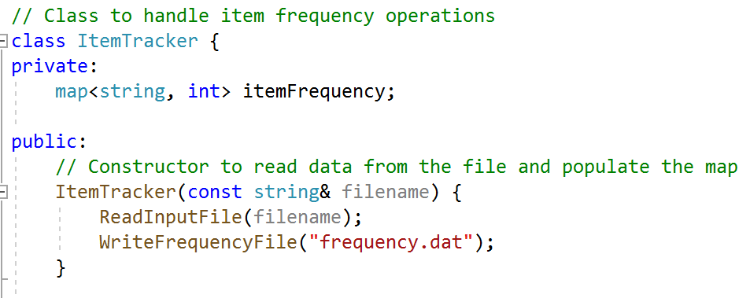

Overall, this program provides an efficient solution for tracking item frequencies in small-scale inventory or retail scenarios. By allowing users to analyze purchasing trends through multiple formats, it offers valuable insights while maintaining simplicity and ease of use.